**Britvic- Orphaned volume check**

**Step 1:** Go to Britvic -gen-ra1-pr

**Step 2:**  Go to the volume

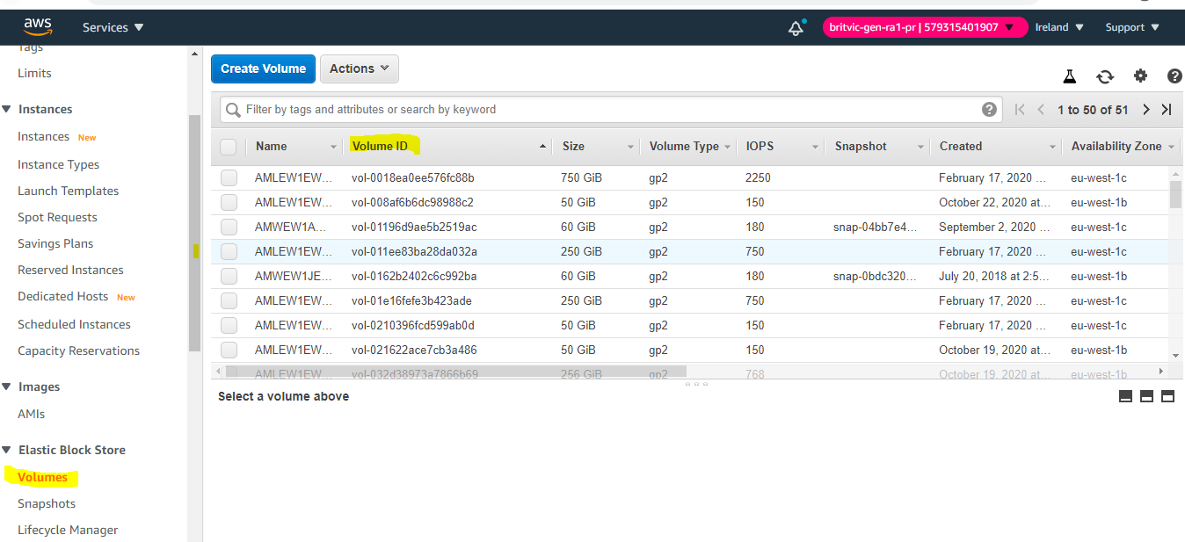

**Step 3:**

Check the volume ID if anything orphaned or not that means volume should associated with any resource(E.g of orphaned volume is as highlighted)

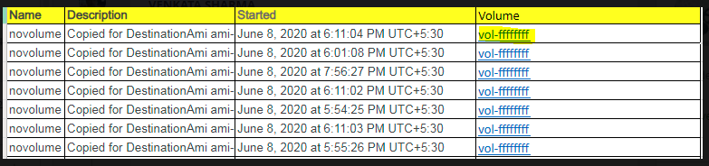

**Step 4:** repeat this steps from 1 to 3 for all the four Britvic accounts.

Britvic-gen-ra1-pr

Britvic-gen-ra2-pr

Britvic-gen-ra3-pr

Britvic-gen-ra4-pr

**Step 5**: Gather all the orphaned volumes and sent mail to Chetan for further proceedings.